
Politecnico di Milano – V Facoltà di Ingegneria

075274 e 070644 - Sistemi distribuiti (con laboratorio)
Prof. G. Cugola

Appello del 3 Febbraio 2010
Rules:
- You are not allowed to use books, notes, or other material.
- You can answer in Italian or English.
- Total time for the test: 2 hours.

- Implement in Java a PriorityBuffer class, which realizes an integer buffer for a single element with priority on consumers. It provides a put method to insert a new value into the buffer. If the buffer is full the method suspends the caller. Analogously, method get takes a value between 0 and 10 as the priority of the caller and returns the value into the buffer, if any, or suspends the caller. Priorities are used to decide which one among the suspended getters wake-up when a new element is inserted into an empty buffer: one among the highest priority getters waiting.

- Describe structured naming and how to implement it using a distributed name server.

- Describe how to use vector clocks for causal delivery. Is it possible to use scalar clocks? Explain.

- Calculates the recovery line for the two diagrams below using the rollback-dependency graph for the first on, the checkpoint dependency graph for the second one.

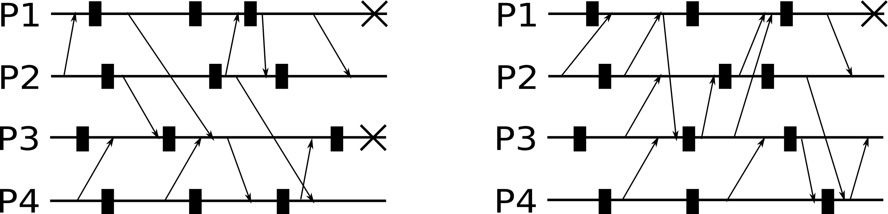

- Under some assumptions it is actually possible to reach consensus in a group of failing processes. Describe these assumptions, the algorithm for consensus, and prove it is correct.
- Consider a distributed data store, as shown in figure. The store contains a numeric variable x, with initial value set to 0.
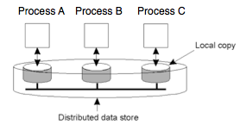
Three processes, A, B, and C interact with the store, running the following instructions.

A: while(true) {
if (x<3) x++;
}

B: while(true) {
if (x>0) x--;
}

C: while(true) {
if (x>0) x--;
}

The following requirement has to be satisfied: “Each process must always read a value of x between 0 and 3 (0 and 3 included)”
Consider 4 implementations (1, 2, 3, 4) with the following properties.
- The store presents a FIFO consistency model. Read and write operations are considered as separate instructions.
- The store presents a sequential consistency model. Read and write operations are considered as separate instructions.
- The store presents a FIFO consistency model. A read operation, the condition evaluation and the subsequent write operation are considered as a single atomic instruction.
- The store presents a sequential consistency model. A read operation, the condition evaluation and the subsequent write operation are considered as an atomic instruction.
In all implementations, when a write operation is performed, the new value of x (and not an identifier of the operation) is propagated to all replicas.
Write, for each implementation, if described properties are sufficient to satisfy the requirement. If not, show an example in which it is violated.

- Consider secure channels for secure communication between hosts in a distributed system.
- Which kinds of attack do secure channels offer protection against?
- Which attacks are not considered?
- Which assumptions have to be done for the enstablishment of secure channels? Why are they needed?
- Describe the different mechanisms that can be used to enstablish secure channels. For each of them show the main advantages and limitations.

